Lab 14

COnfiguring Network Access Protection (NAP)

This lab contains the following exercises and activities:

|  |  |
| --- | --- |
| Exercise 14.1 | Installing Health Registration Authority Role on an NPS Server |
| Exercise 14.2 | Configuring NAP Enforcement for DHCP |
| Exercise 14.3 | Configuring SHV and Health Policies |
| Lab Challenge | Configuring Clients for NAP |

BEFORE YOU BEGIN

The lab environment consists of student workstations connected to a local area network, along with a server that functions as the domain controller for a domain called *contoso.com*. The computers required for this lab are listed in Table 14-1.

Table 14-1

Computers Required for Lab 14

|  |  |  |
| --- | --- | --- |
| Computer | Operating System | Computer Name |
| Server (VM 1) | Windows Server 2012 | RWDC01 |
| Server (VM 2) | Windows Server 2012 | Server01 |

In addition to the computers, you also require the software listed in Table 14-2 to complete Lab 14.

Table 14-2

Software Required for Lab 14

|  |  |
| --- | --- |
| Software | Location |
| Lab 14 student worksheet | Lab14_worksheet.rtf (provided by instructor) |

Working with Lab Worksheets

Each lab in this manual requires that you answer questions, take screen shots, and perform other activities that you will document in a worksheet named for the lab, such as Lab14_worksheet.rtf. You will find these worksheets on the book companion site. It is recommended that you use a USB flash drive to store your worksheets, so you can submit them to your instructor for review. As you perform the exercises in each lab, open the appropriate worksheet file using WordPad, fill in the required information, and save the file to your flash drive.

After completing this lab, you will be able to:

* Install Health Registration Authority role on an NPS server
* Install and configure NAP Enforcement using DHCP
* Configure System Health Validators (SHVs)
* Configure health policies
* Configure NAP client settings

Estimated lab time: 60 minutes

|  |  |
| --- | --- |
| Exercise 14.1 | Installing Health Registration Authority Role on an NPS Server |
| Overview | Network Access Protection (NAP), which is used to control who can access a network based on the security health of a client, is one of the more complicated installations during this course. Before you can configure NAP, you must add the Health Registration Authority role to the current NPS installation on RWDC01 so that it can monitor the connections on the NPS server.. |
| Completion time | 10 minutes |

**Mindset Questions: So far, you have configured NPS. However, NPS also supports Network Access Protection. Explain what NAP is and how it is used to protect your network?**

**1.** Log in to RWDC01 as the **Contoso\administrator** user account. The Server Manager console opens.

**2.** On Server Manager, click Manage and click Add Roles and Features. The Add Roles and Feature Wizard opens.

|  |  |
| --- | --- |
| Question 1 | To use NAP with DHCP, which server do you need to install NPS on? |

**3.** On the Before you begin page, click Next.

**4.** Select *Role-based or feature-based installation*, and then click Next.

**5.** On the Select destination server page, click Next.

**6.** On the Select server roles page, expand *Network Policy and Access Services (Installed)*, click to select Health Registration Authority and click Next.

**7.** When you are asked to add features that are required for Health Registration Authority, click Add Features.

**8.** On the Select server roles page, click Next.

**9.** On the Select features page, click Next.

**10.** On the Network Policy and Access Services page, click Next.

**11.** Click *Use the local CA to issue health certificates for this HRA server*. Click Next.

**12.** On the Authentication Requirements page, select the *Yes, required requestors to be authenticated as members of a domain. (recommended)*. Click Next.

**13.** On the Server Authentication Certificate page, make sure Choose an existing certificate for SSL encryption (recommended) is already selected. Click to highlight RWDC01.contoso.com, then click Next.

**14.** On the Confirm installation selection page, click Install.

**15.** When the installation is complete, click Close.

End of exercise. You can leave the windows open for the next exercise.

|  |  |
| --- | --- |
| Exercise 14.2 | Configuring NAP Enforcement for DHCP |
| Overview | During this exercise, you configure NAP enforcement for DHCP, specify the remediation servers, and enable NAP for a DHCP scope. |
| Completion time | 20 minutes |

**Mindset Question: When you configure NAP enforcement for DHCP, what are the basic steps that must be performed?**

**1.** On RWDC01, right-click the Start button, and select Command Prompt (Admin).

**2.** At the command prompt, execute the **napclcfg.msc** command. The NAP Client Configuration console opens, as shown in Figure 14-1.

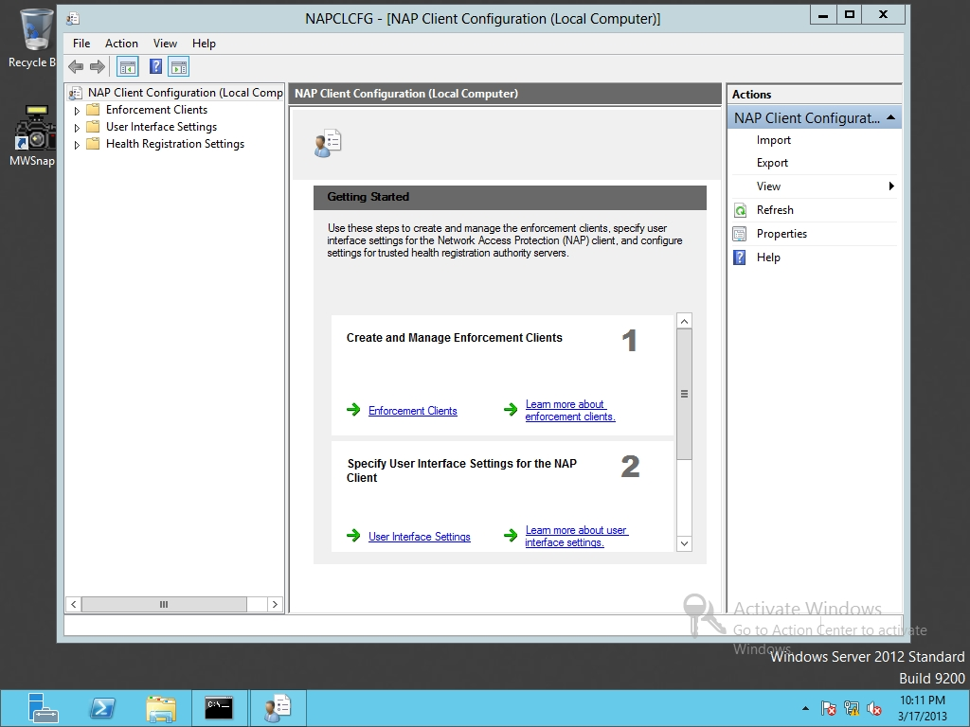

Figure 14-1

Opening the NAP Client Configuration

**3.** In the left pane, click Enforcement Clients.

**4.** In the center pane, double-click DHCP Quarantine Enforcement Client to open the DHCP Quarantine Enforcement Client Properties dialog box.

**5.** Select the Enable this enforcement client option. Click OK to close the DHCP Quarantine Enforcement Client Properties dialog box.

**6.** Take a screen shot of the NAP Client Configuration window by pressing Alt+Prt Scr and then paste it into your Lab14_worksheet file in the page provided by pressing Ctrl+V.

**7.** Close the NAP Client Configuration Client console.

**8.** At the command prompt, execute the **services.msc** command.

**9.** Scroll down and find the Network Access Protection Agent. Then double-click the Network Access Protection Agent service to open the Network Access Protection Agent Properties dialog box.

**10.** Change the Startup type to Automatic.

**11.** Take a screen shot of the Network Access Protection Agent Properties dialog box by pressing Alt+Prt Scr and then paste it into your Lab14_worksheet file in the page provided by pressing Ctrl+V.

**12.** Click the Start button.

**13.** After the service is started, click OK to close the Network Access Protection Agent Properties dialog box.

**14.** Close the Services console and close the command prompt.

**15.** Using Server Manager, open the Tools menu and click Network Policy Server. The Network Policy Server console opens.

**16.** In the main pane, click Configure NAP to start the Configure NAP Wizard (as shown in Figure 14-2).

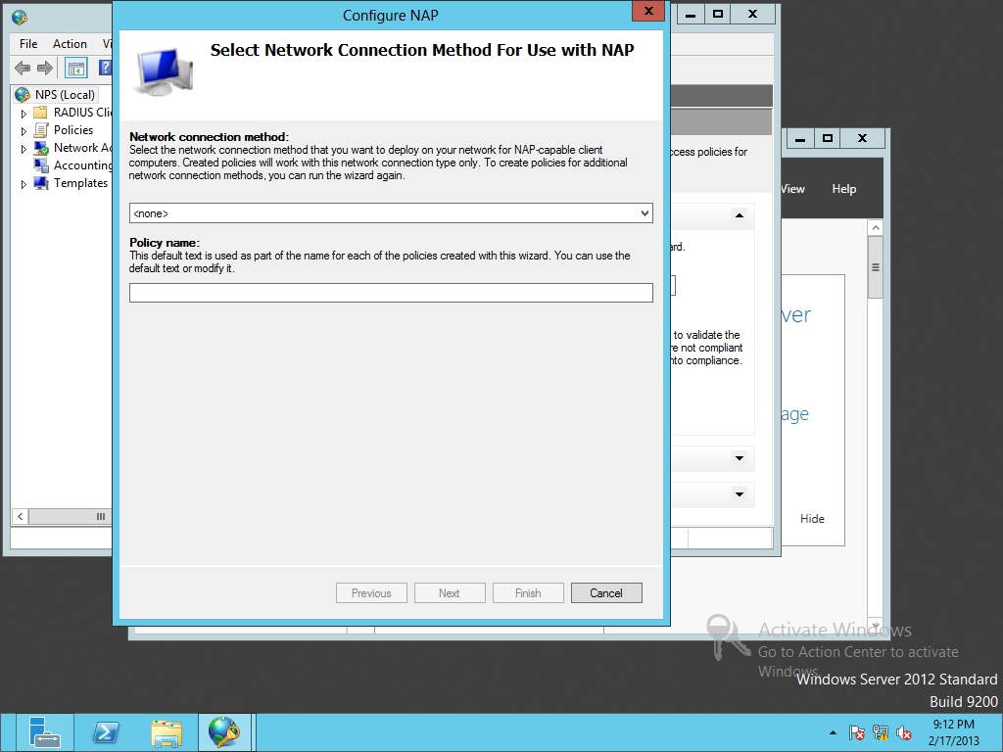

Figure 14-2

Configuring NAP

**17.** When the Select Network Connection Method For Use with NAP Wizard opens, select the Dynamic Host Configuration Protocol (DHCP) for the network connection method from the drop-down list. Click Next.

**18.** On the Specify NAP Enforcement Servers Running DHCP Server page, because Server01 is already running DHCP, click Next.

**19.** On the Specify DHCP Scopes page, click the Addbutton to open the MS-Server Class page (as shown in Figure 14-3). Type **NAP DHCP** in the text box and click OK. On the Specify DHCP Scopes page, click Next.

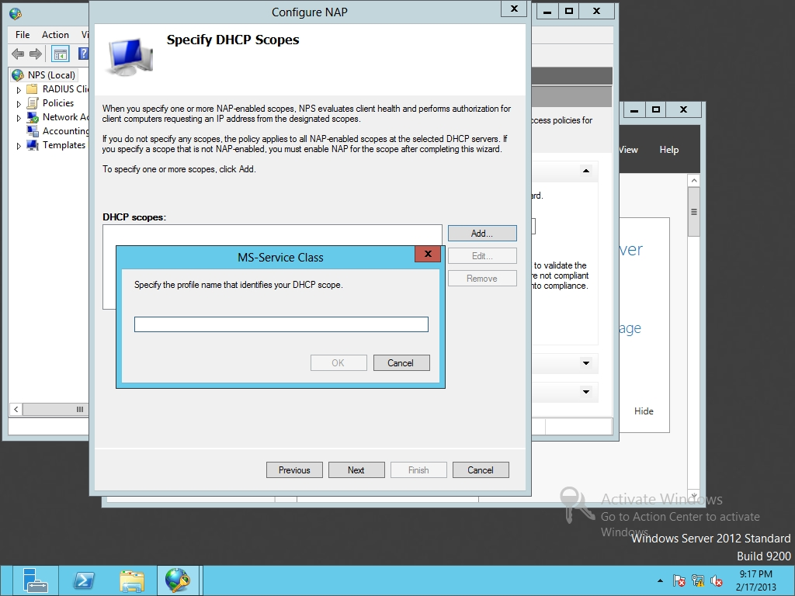

Figure 14-3

Configure the MS-Service Class

**20.** On the Configure Machine Groups page, click the Add button to open the Select Group dialog box. In the Enter the object name to select text box, type **domain computers** and click OK. Click Next.

**21.** On the Specify a NAP Remediation Server Group and URL page (as shown in Figure 14-4), click New Group. In the Group Name text box, type **Remediation Servers**.

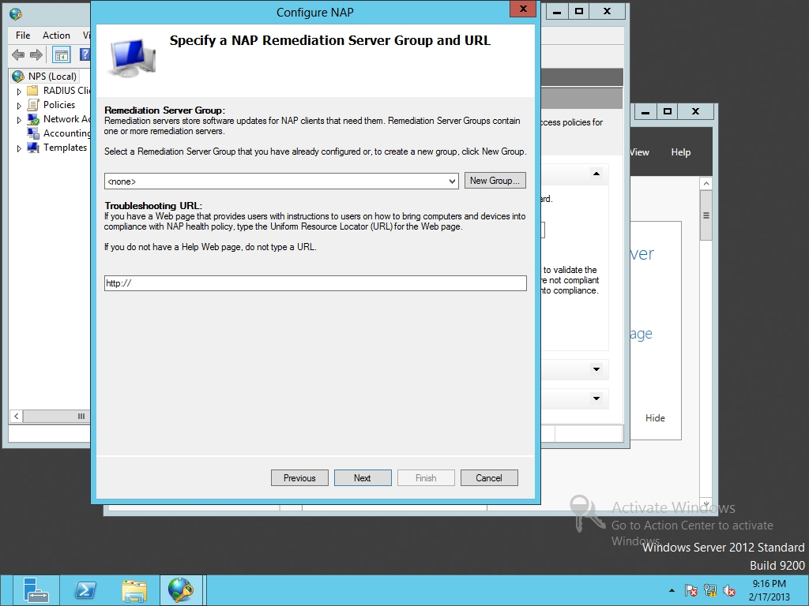

Figure 14-4

Specifying the NAP remediation server group and URL

|  |  |
| --- | --- |
| Question 2 | What remediation servers should you include? |

**22.** Click the Add button. In the Friendly name text box, type **Server01**. For the IP address or DNS name, type **Server01.contoso.com** and click Resolve. Click OK to close the Add New Server and click OK to close the New Remediation Server Group dialog box. Click Next.

**23.** On the Define NAP Health Policy page, click Next.

**24.** On the Completing NAP Enforcement Policy and RADIUS Client Configuration page, click Finish.

**25.** Using Server Manager, open the Tools menu and click DHCP. The DHCP console opens.

**26.** Expand the server node and expand the IPv4node.

**27.** Click Scope [192.168.1.0]. Then right-click Scope [192.168.1.0] and click Properties. A Scope Properties dialog box opens.

**28.** Click the Network Access Protection tab, as shown in Figure 14-5.

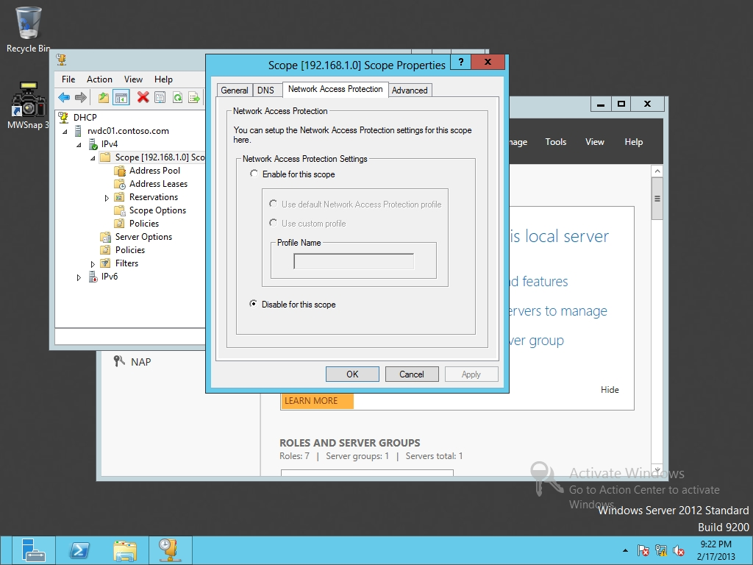

Figure 14-5

Enabling Network Access Protection

**29.** Click Enable for this scope.

**30.** Click OK to close Scope Properties dialog box.

**31.** Close DHCP console.

End of exercise. You can leave the windows open for the next exercise.

|  |  |
| --- | --- |
| Exercise 14.3 | Configuring SHV and Health Policies |
| Overview | During this exercise, to enforce NAP, you configure System Health Validator and Health Policies. |
| Completion time | 10 minutes |

**1.** On RWDC01, using Server Manager, open Tools, and open Network Policy Server.

**2.** Expand Network Access Protection, expand System Health Validators, expand Windows Security Health Validator, and click Windows Security Health Validator.

**3.** Click Settings, then double-click Default Configuration. The Windows Security Health Validator dialog box opens as shown in Figure 14-6.

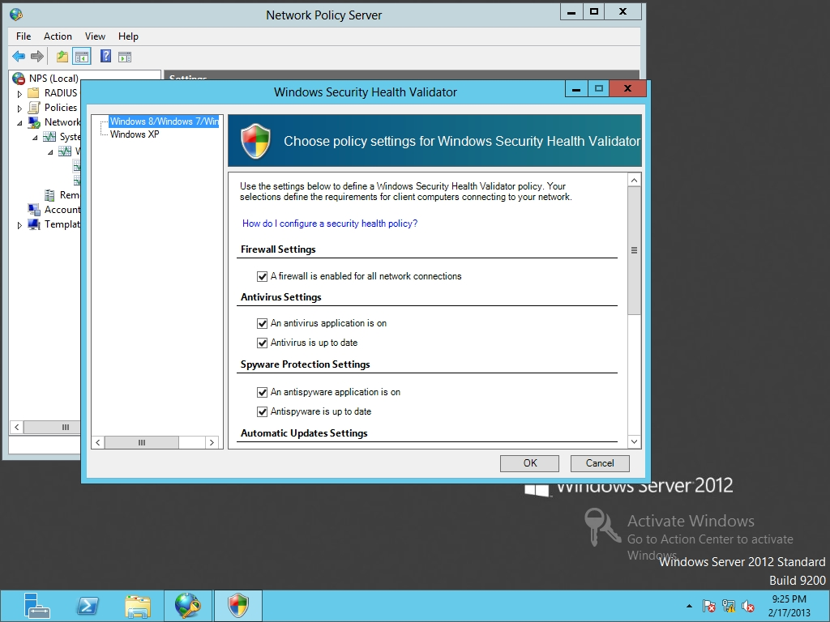

Figure 14-6

Configuring the Windows Security Health Validator

|  |  |
| --- | --- |
| Question 3 | Which options are already selected for the Windows Security Health Validator? |

**4.** Click OK to close the Windows Security Health Validator.

**5.** In the NPS console, under Policies, click Health Policies.

**6.** Double-click NAP DHCP Compliant.

|  |  |
| --- | --- |
| Question 4 | Which Windows Security Health Validator is configured? |

|  |  |
| --- | --- |
| Question 5 | What is the Client SHV checks configured as? |

**7.** Click OK to close the NAP DHCP Compliant Properties.

**8.** Double-click NAP DHCP Noncompliant.

|  |  |
| --- | --- |
| Question 6 | What is the Client SHV checks configured as? |

**9.** Click OK to close the NAP DHCP Noncompliant Properties.

**10.** Close Network Policy Server console.

Lab REview Questions

|  |  |
| --- | --- |
| **Completion time** | **10 minutes** |

**1.** In Exercise 14.1, you installed support for the Health Registration Authority. What does the Health Registration Authority do?

**2.** In Exercise 14.2, what command opened the NAP Client Configuration console?

**3.** In Exercise 14.2, what allows a computer to get Windows update so that it can be compliant when using NAP?

**4.** In Exercise 14.3, when using NAP, what defines the requirements for client computers that connect to the network?

|  |  |
| --- | --- |
| Lab Challenge | Configuring Clients for NAP |
| Overview | To complete this challenge, you will explain how to configure clients for NAP by writing the highlevel steps to complete the tasks described in the scenerio. |
| Completion time | 10 minutes |

So far, you have configured NAP on the servers. You now need to configure NAP for the clients. Explain how to enable Security Center and to automatically start Network Access Protection Agent services.

Write out the steps you performed to complete the challenge.

End of lab. You can log off or start a different lab. If you want to restart this lab, you’ll need to click the End Lab button in order for the lab to be reset.